Phase 1— Brainstorming and Idea Prioritization
Implement Client Script & UI Policy (Incident)
01 October 2026 | Phase 1 | SWTID-2026-4755
Field | Project value
Date | 01 October 2026
Team ID | SWTID-2026-4755
Project Name | Implement Client Script & UI Policy (Incident)
Phase 1 focus | Generate, compare, and prioritize solutions for Incident data quality
1. Project challenge used for ideation
Incident records must be complete and consistent for triage, routing, resolution, SLA compliance, and reporting. The supplied implementation project identifies a specific opportunity: enforce conditional field behavior and save-time validation directly in the ServiceNow Incident interface instead of relying only on user memory or manual review.
2. Brainstorming question
How might we help service desk agents create trustworthy high-impact Incidents quickly, while preventing incomplete ownership, inconsistent urgency, and unsafe direct State edits?
3. Idea generation
ID | Idea | User value | Feasibility
I-01 | High Impact Control UI Policy | Activates stronger controls only when Impact is 1 – High. | High
I-02 | Automatic Urgency alignment | Sets Urgency to High when Impact changes to High. | High
I-03 | Save-time Assigned To validation | Prevents incomplete high-impact records from entering workflow. | High
I-04 | Block State list editing | Protects workflow transitions from context-free list edits. | High
I-05 | Incident quality checklist | Guides agents through Impact, group, owner, urgency, and State checks. | Medium
I-06 | Server-side data policy extension | Adds integration/API protection beyond the client UI. | Medium; follow-on
I-07 | Agent quality dashboard | Reports incomplete or corrected Incidents over time. | Medium; follow-on
I-08 | AI-based priority recommendation | Predicts urgency or routing from description text. | Low for current scope; unnecessary
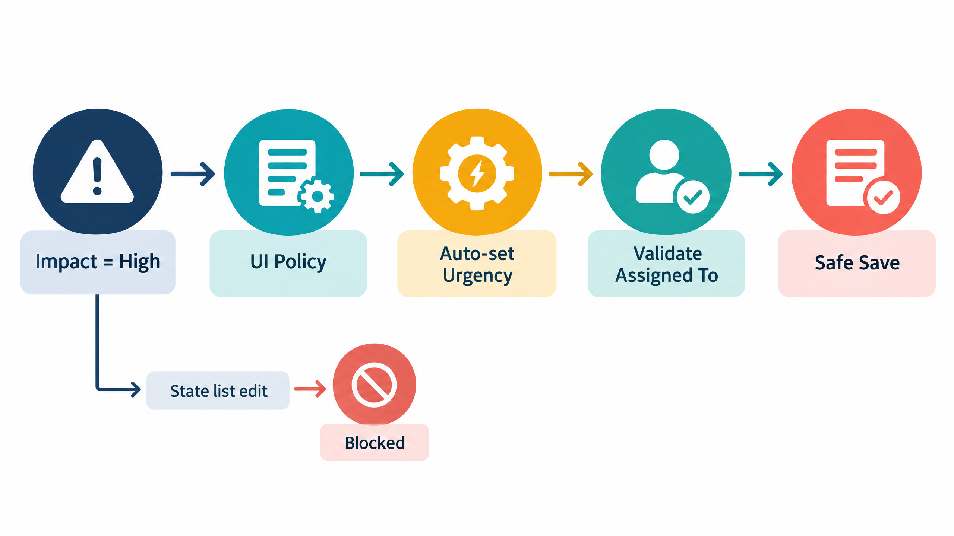
Generated project visual: the rule path brainstormed for Impact, Urgency, ownership, and State safety.
4. Prioritization criteria
Ideas were compared using user impact, alignment with the supplied project objective, implementation effort, explainability, reversibility, and testability. The highest priority goes to controls that solve the stated problem without adding an external service or unpredictable behavior.
Idea | Impact | Alignment | Effort | Explainability | Priority
I-01 High Impact Control UI Policy | 5 | 5 | 2 | 5 | 1
I-02 Urgency automation | 5 | 5 | 2 | 5 | 2
I-03 Assigned To validation | 5 | 5 | 2 | 5 | 3
I-04 State list-edit protection | 4 | 5 | 2 | 5 | 4
I-05 Quality checklist | 3 | 4 | 3 | 4 | 5
I-06 Server-side extension | 5 | 4 | 4 | 5 | 6
I-07 Quality dashboard | 3 | 3 | 4 | 4 | 7
I-08 AI recommendation | 2 | 2 | 5 | 2 | 8
5. Selected solution concept
Select a coordinated ServiceNow control pattern: one reversible UI Policy named High Impact Control, a UI Policy Action for Assignment group, a UI Policy Action that makes Urgency read-only, and three Client Scripts for onChange, onSubmit, and onCellEdit behavior.
• The solution activates when Impact = 1 – High.
• Assignment group becomes mandatory for high-impact routing.
• Urgency is automatically set to High and controlled by the policy.
• Assigned To is checked before save.
• State cannot be changed directly from list editing.
• Reverse if false restores normal behavior when Impact changes away from High.
6. Why this idea wins
The selected idea is native to ServiceNow, easy to explain to agents and administrators, small enough for a focused micro-project, and directly traceable to the supplied PDF tasks. It improves consistency without inventing a new data model, analytics stack, AI model, or external API dependency.
7. Phase 1 decision
Proceed to problem definition and requirement analysis with the combined UI Policy + Client Script concept as the baseline solution. Capture future enhancements separately so the initial delivery remains deterministic and testable.

